**ASSIGNMENTS**

1. Create the startup script for an application start and stop

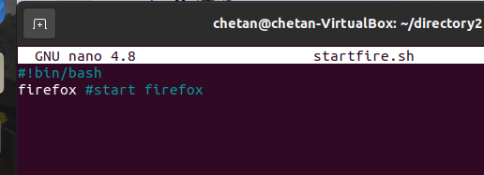

2. Write a shell script that consists of a function that displays the number of files in the present working directory. Name this function “file_count” and call it in your script. If you use variable in your function, remember to make it a local variable.

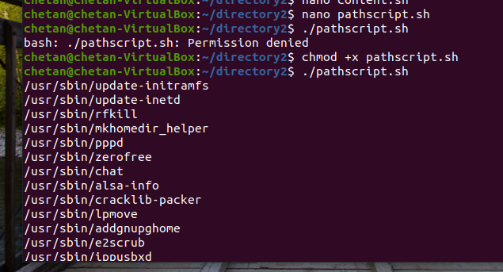

4.Display the names of any file-system which have less than 10% free space available

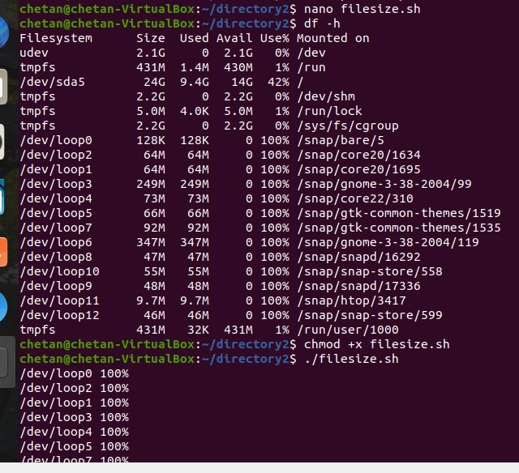

5. Write a script that takes any number of directories as command-line arguments and then lists the contents of each of these directories.

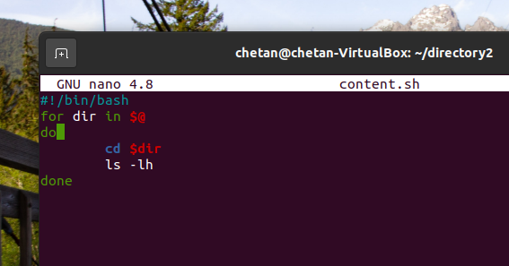

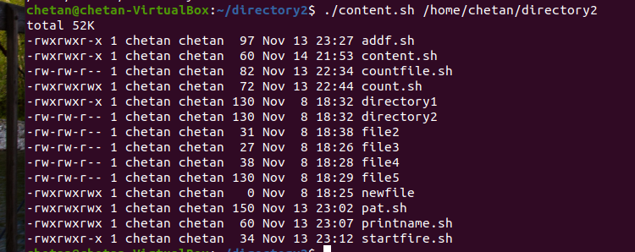

**PRACTICE**

Printing a name

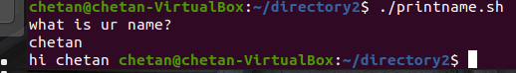

Pattern

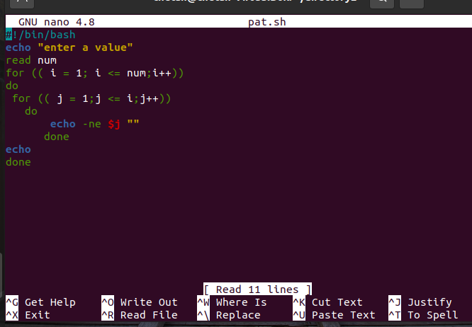

Start firefox application





To add 2 floating point numbers

